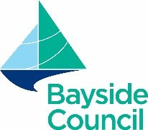
High School Category

Entry Form

Student’s Details
Student’s full name |  | School
Class |  | Age
Title of work
Parent / Guardian / Teacher Details
Name
Address
Phone |  | Email
Permission is given to make my entry available on Bayside Council’s online platforms (please tick the appropriate box) |  | Yes | No

Parent / Guardian / Teacher Declaration
- I have read the Ron Rathbone Local History Competition Guidelines and I agree to abide by the conditions of entry.
- The entry submitted is the student’s own work.
- I understand a copy of the work may be placed in the Local History Collection of Bayside Library Service and on Bayside Council’s online platforms.
- Winner details may be published in media sources subject to the approval by the entrant / parent / guardian / teacher.

Date:
Parent / Guardian / Teacher signature:

Submission
  - Email: Soft copy entries in Word or PDF format to: local_history@bayside.nsw.gov.au
  - Website: www.bayside.nsw.gov.au/ronrathbone

It is the responsibility of the entrant to ensure that his or her entry is properly submitted and received All entries must be received by 5pm, Thursday 17 July 2025

For enquiries, please contact a member of the Local History Team, by emailing local_history@bayside.nsw.gov.au

